July 15, 2024

Dear Parents/Guardians:

As HISD Nutrition Services prepares for the 2024 – 2025 school year, we are required to evaluate all school campuses’ eligibility within the district to participate in the Texas Department of Agriculture Child Nutrition Programs.

You are required to complete the Free / Reduced–Price Meals Household Application for School Year 2024 – 2025 for School Meals. The application process will identify each student as Free, Reduced, or Paid for all meals/snacks consumed. Student eligibility status is kept confidential. Parents/guardians can complete the application at https://schoolcafe.com/HoustonISD and new applications will begin the evaluation process the week of August 12th. The following QR codes are also available for access to the school meal application and instructions.


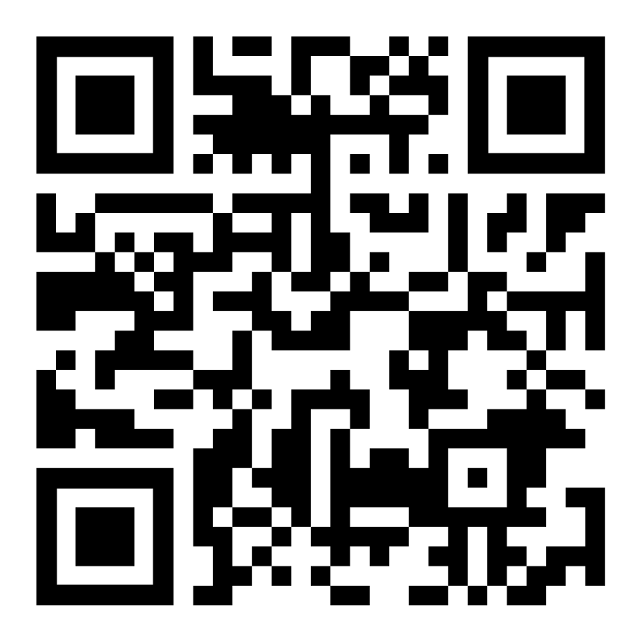
School Meal Application School Meal Application Instructions

Nutrition Services provides quality customer service throughout the meal application process. For additional questions, call the Student Eligibility and Accountability Department at 713-491-5944.

Sincerely,
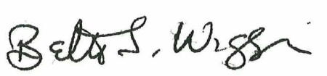

Nutrition Services, Officer

